A PERFORMANCE INVESTIGATION OF A FOUR-SWITCH THREE-PHASE INVERTER-FED IM DRIVES AT LOW SPEEDS USING FUZZY LOGIC AND PI CONTROLLERS
ABSTRACT
This paper presents a speed controller using a fuzzylogic controller (FLC) for indirect field-oriented control (IFOC) of induction motor (IM) drives fed by a four-switch three-phase (FSTP) inverter. In the proposed approach, the IM drive system is fed by an FSTP inverter instead of the traditional six-switch three-phase (SSTP) inverter for cost-effective low-power applications. The proposed FLC improves dynamic responses, and it is also designed with reduced computation burden. The complete IFOC scheme incorporating the FLC for IM drives fed by the proposed FSTP inverter is built in MATLAB/Simulink, and it is also experimentally implemented in real time using a DSP-DS1103 control board for a prototype 1.1-kW IM. The dynamic performance, robustness, and insensitivity of the proposed FLC with the FSTP inverter-fed IM drive is examined and compared to a traditional proportional-integral (PI) controller under speed tracking, load disturbances, and parameters variation, particularly at low speeds. It is found that the proposed FLC is more robust than the PI controller under load disturbances, and parameters variation. Moreover, the proposed FSTP IM drive is comparable with a traditional SSTP IM drive, considering its good dynamic performance, cost reduction, and low total harmonic distortion (THD).

BLOCK DIAGRAM FOR PROPOSED SYSTEM
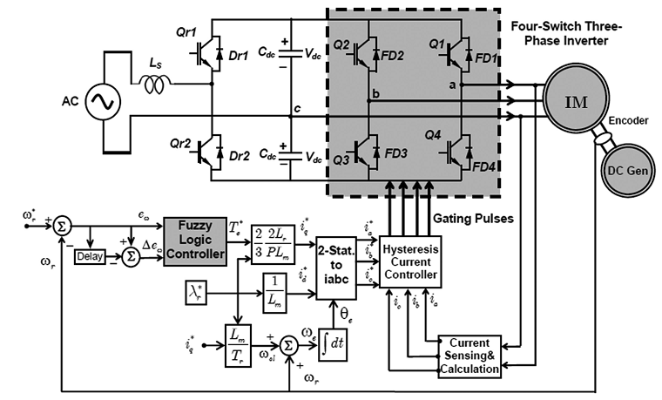
Fig. 1. Block diagram of the proposed FLC-based IFOC scheme of the IM drive fed by FSTP voltage source inverter.
DESIGNG SOFTWARE AND TOOLS:
MAT LAB /SIMULATION Software and simu power systems tools are used. Mainly control system tools, power electronics and electrical elements tools are used.

